**Activity 1 -Aggregate Functions**

**Exercise 1**

SELECT

COUNT(employee_id) AS 'No of Employees in Sales'

FROM

employees INNER JOIN departments on

employees.department_id = departments.department_id

WHERE department_name = 'Sales';

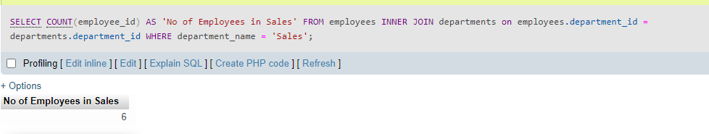

**Exercise 2**

SELECT

department_name,

COUNT(department_name) AS 'No of Employees per dept'

FROM

employees

INNER JOIN

departments ON departments.department_id = employees.department_id

GROUP BY

department_name;

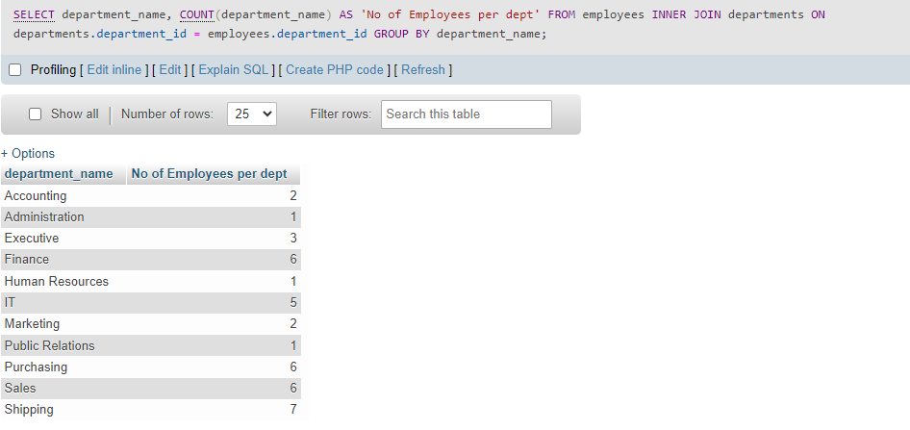

**Exercise 3**

SELECT

m.first_name || ' ' || m.last_name AS manager,

count(e.employee_id) AS headcount

FROM

employees e

LEFT JOIN

employees m ON m.employee_id = e.manager_id

GROUP BY manager

ORDER BY manager;

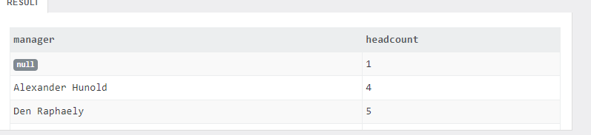  

**Exercise 4**

SELECT

e.employee_id,

COUNT(d.dependent_id) As NoOfDependents

FROM

employees e

LEFT JOIN dependents d ON d.employee_id = e.employee_id

GROUP BY

e.employee_id

HAVING

NoOfDependents = 2;

Number of records = None from the sample database

Exercise 5

SELECT

department_id,

SUM(salary) As 'Total Salary'

FROM

employees

GROUP BY

department_id;

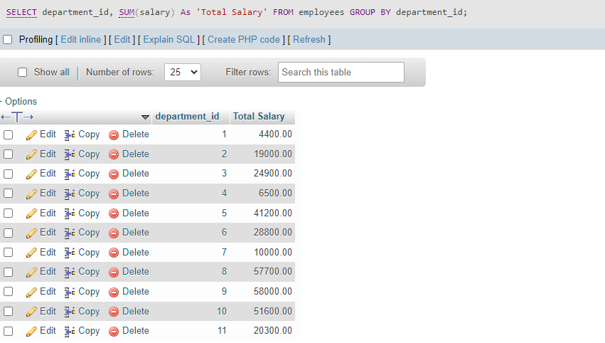

Total number of records = 11

**Exercise 6**

SELECT

ROUND(AVG(max_salary),2) AS 'Average of Max Salary'

FROM

jobs;

